To complete this assignment I have used VSTS tool by Microsoft. I have prepared a report for Business Scenario – Demoblaze application which is there in Demoblaze Business Scenario - Performance Report.pdf.

For API test I am able to achieve 2.5 requests/sec for AddPet API in 30 min test.

I have also provided result summary for AddPetAPI loadtest and Business Scenarios loadtest in ResultDocuments_VSTSSummary folder. Both word document as well as .trx file is there. Trx file you can directly open in visual studio to view the test result.

1. **How to run the tool?**

* In order to perform load testing in VSTS (Visual studio Team Services), we need visual studio enterprise edition.
* While installing visual studio, we need to select Web Performance and Load testing component under Debugging and Testing section. If visual studio is already installed you can add this component via Tools-> Get Tools And Features. 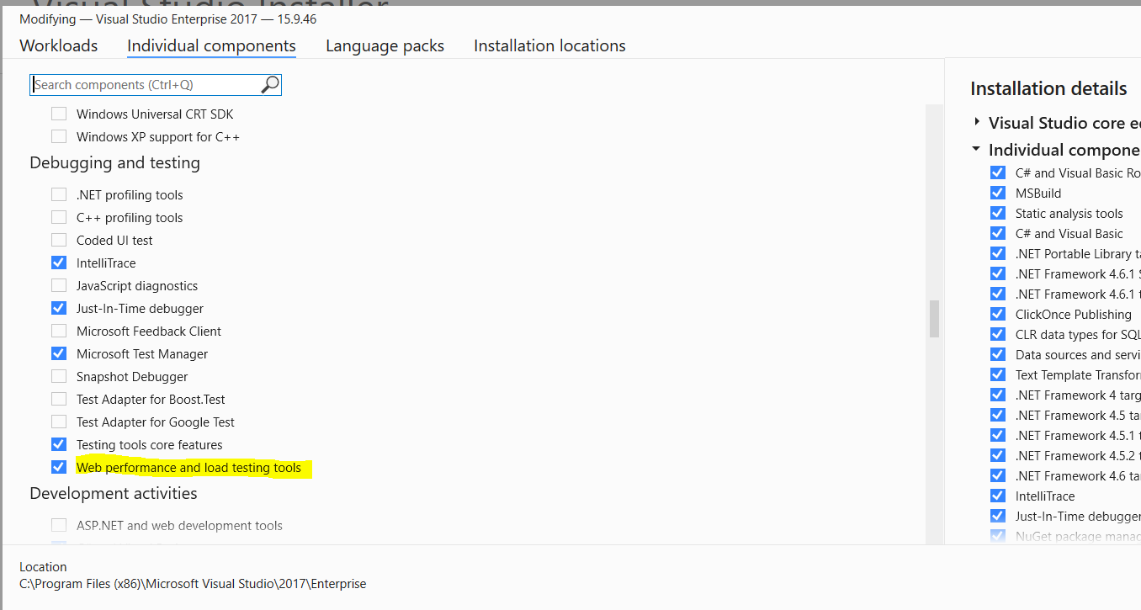
* Once above component is installed, you will be able to create/open web performance and load test project.

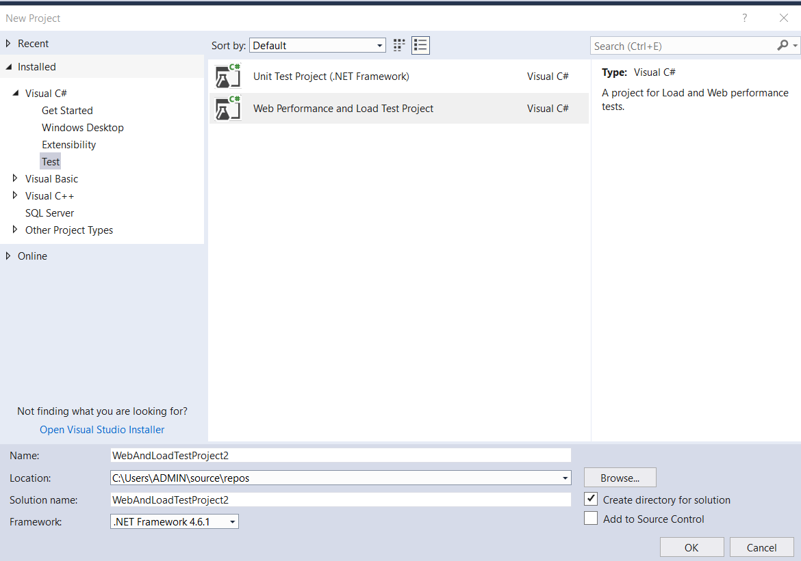

* This tool use Loadtest2010 database as back end database to write transactions statistics of loadtest. In zip file CreatingLoadTestRepdository.sql. You can run this file by updating path for .mdf and .ldf file to create Loadtest2010 DB. Or else I have also provided .mdf file on my machine that I have used while loadtesting. You can import that file in SSMS.
* In Zip file, I have provided solution folder of the project that I have used for this load testing assignment. Name of the folder is -86400PerfTest. Just open this folder and double click on .sln file. It will open the solution in visual studio.
* In solution folder, there are 2 folders API Test and Business Scenario. These are the folders for question 1 and 2 respectively in this test. API test contains script, webtest and fiddler recording of API and loadtest file named AddPetAPI.loadtest. You can run this loadtest file for API Test.

Business Scenario folder contains loadtest files, input files scripts and recordings. To run business scenario test you need to use Baseline.loadtest file. 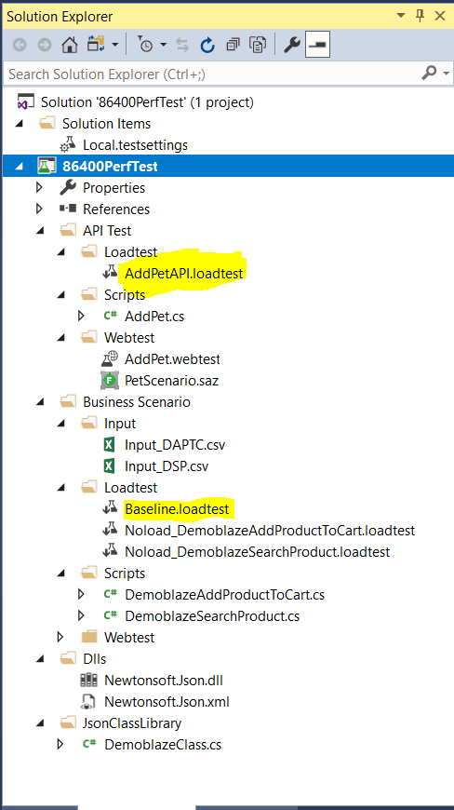

When you open the loadtest file, you need to click on below highlighted icon to run the test. 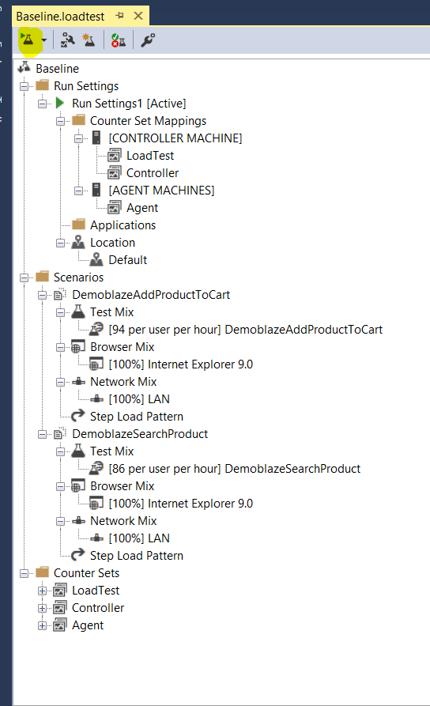

* Before running the loadtest file, go to Loadtest menu-> Manage Test Controller. Select local controller. Check connection string. You can test the connection so that it will make sure result will be written to Loadtest2010 database.

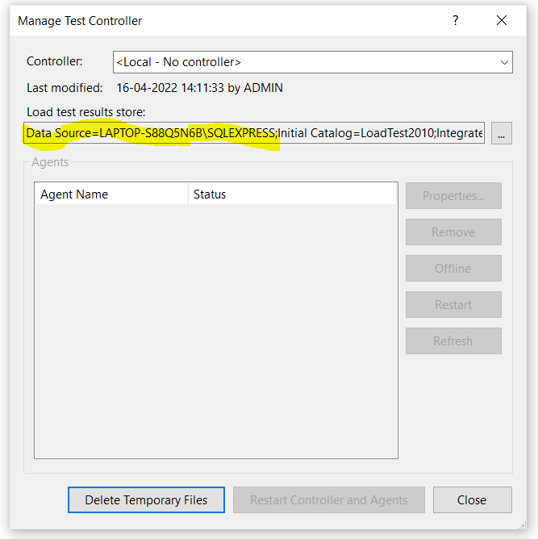

For reference I am providing this msdn link: <https://docs.microsoft.com/en-us/visualstudio/test/quickstart-create-a-load-test-project?view=vs-2022>

Where to look for Test Reports?

* When you run the test, on completion VSTS will show detailed result summary.
* If you have imported .mdf file provided by me and want to check previous result, open the loadtest file for which you want to check the result. Click on highlighted icon in below screenshot. It will open- Open and Manage Loadtest Result.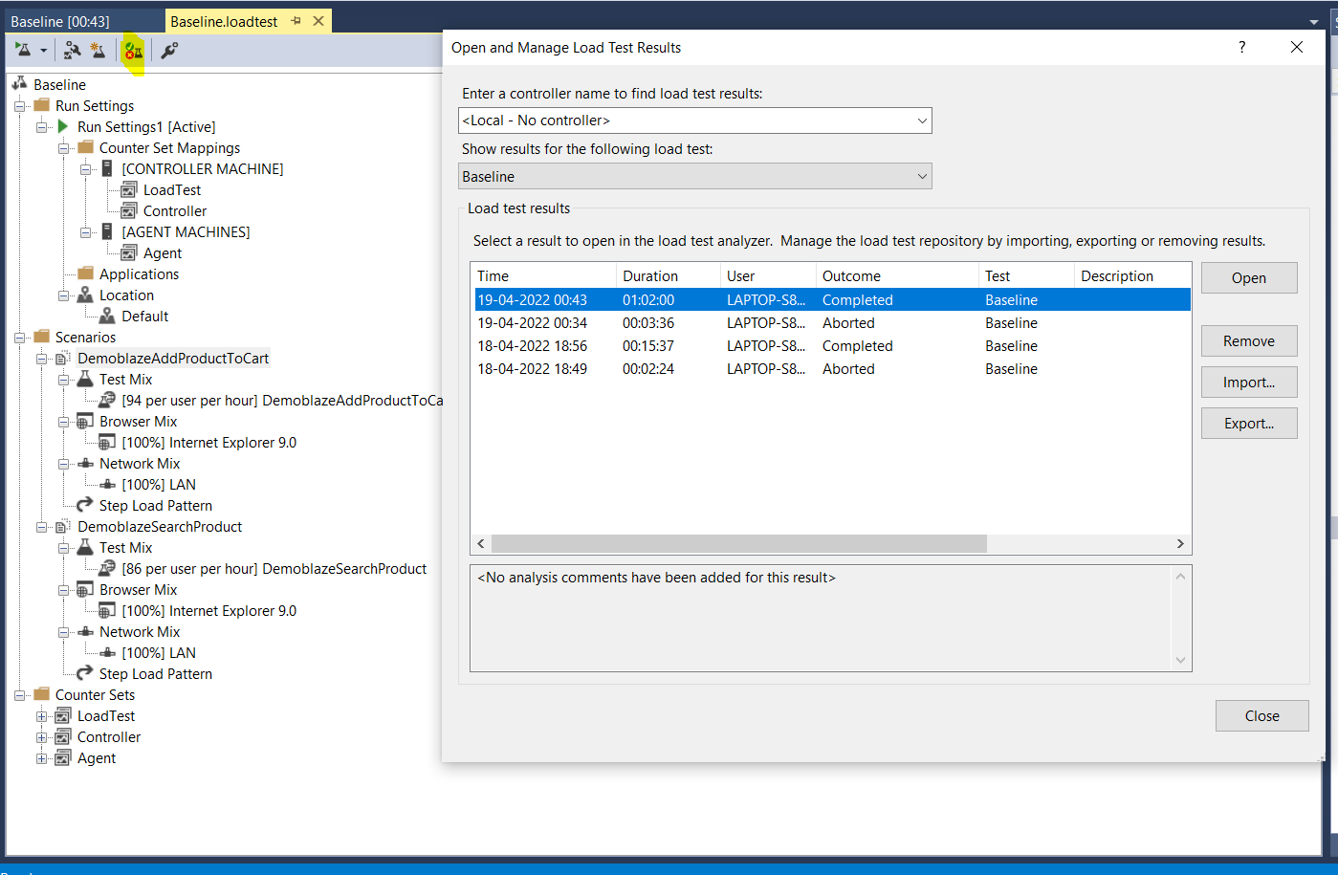

Select last result and open it. It will open result summary.

* I have also provided result summary for AddPetAPI loadtest and Business Scenarios loadtest in ResultDocuments_VSTSSummary folder. Both word document as well as .trx file is there. Trx file you can directly open in visual studio.

*Note: For business scenario- Demoblaze application, I have created 2 scenarios/scripts. Used CSV as input method. Also parameterization, co-relation, web server parameterization. In loadtest I have used 2 min warm up, 3 min cool down, 2 min ramp up and 1 hour steady state.*